Central new york early americas consortium Presents:
“Locating Sources, Finding Voices: Writing the Women of Rendezvous”

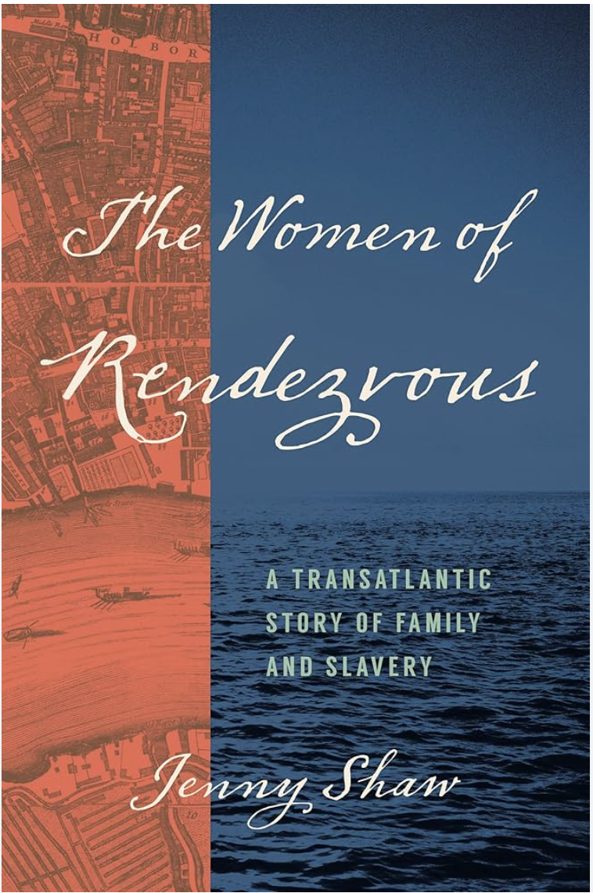
Thursday, October 23 at 4:30pm EST
Guerlac Room
A.D. White House


“Locating Sources, Finding Voices: Writing the Women of Rendezvous”

Join us for a talk with Dr. Jenny Shaw about her new book, which investigates the lives of five women who bore at least twenty children by the same prominent Barbados enslaver and politician in the seventeenth century. Two were his elite English wives, two were women he enslaved, one was a white servant. They first encountered one another on a plantation named Rendezvous in Christ Church parish. Following the death of his second wife, the two enslaved women and the servant traveled to England where they and their children survived and even thrived in early eighteenth-century London. In this talk Jenny Shaw discusses the long, winding, and fraught archival path that first alerted her to this polygynous household, and the equally challenging process of working out how to write a history that does justice to the lives of the remarkable women and children at its heart.

